Wrap It Up!
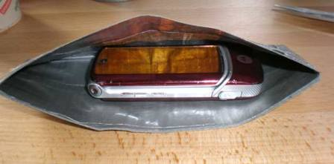

1) Call your lab partner’s cell phone using your cell phone. Are you able to make a connection? If not, you both may need to stand near a window.
2) Wrap one cell phone in aluminum foil. Now use the unwrapped cell phone to call the wrapped phone. Does the wrapped phone receive the signal? Why do you think this happens?
3) Does the aluminum foil have to cover the entire phone in order to block incoming call? Try it and see.
4) A Faraday cage is an enclosure formed by conducting material. Such an enclosure blocks out external electromagnetic fields and radiation. In this activity the Faraday cage is the enclosure formed out of aluminum foil. Can you think of examples of other Faraday cages in everyday life? (See photos below)


