Tuning Fork Interference
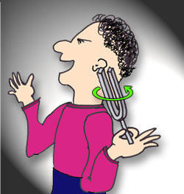
Strike a tuning fork with a rubber hammer or on the heel of your shoe. (Please do not strike the tuning fork on the edge of the table.) Place the vibrating tuning fork near your ear. Slowly rotate the vibrating tuning fork and note any variation in the intensity (loudness) of the sound. Make certain that you rotate the tuning fork through 360 degrees.
What do you hear?

Can you explain your observation?

