The Simplest Motor?
A very simple motor, such as the one in the photograph, can be constructed by following the steps below.

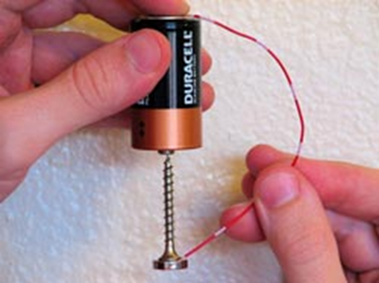
Try It!
1. Obtain a battery, a small nail, a neodymium disc magnet, and a length of wire made from a non-ferromagnetic material such as copper.
2. Magnetically attach the head of the nail to one side end of the magnet.
3. While holding the battery in one hand, with the positive terminal of the battery pointing downward, bring the tip of the nail in contact with the positive terminal of the battery. The nail and magnet should now be attached to and hanging from the positive terminal of the battery.
4. Hold one end of the wire to the negative terminal of the battery while touching the other end of the wire to the side of the magnet.
5. Watch the nail and magnet spin!

