The Old Table Cloth Trick

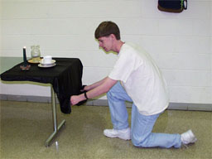

1. Place some old dishes (you may want to begin with a single
plate) on a smooth tablecloth.

2. Grab both ends of the tablecloth and, without hesitation, pull
the tablecloth out from under the dishes as quickly as you can.

3. Did the dishes move? Why do you think the dishes remain
virtually motionless when the tablecloth was quickly pulled
out from under them?

4. Why was a smooth tablecloth used? What do you think would
happen if a rough material, for example, sandpaper, were
used?

