“The Mysterious Glowing Ball”
Additive Color Mixing in Time

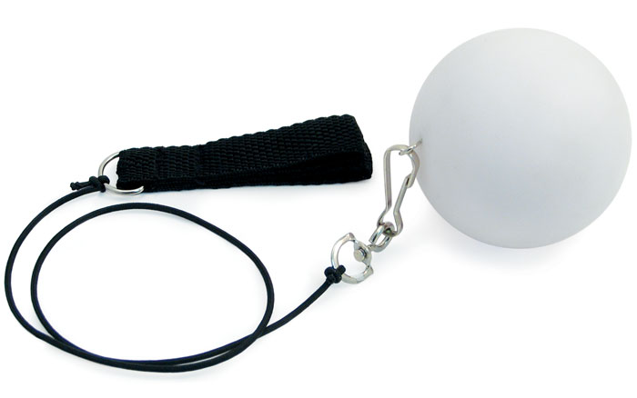

Try It!

1. Turn the light on by twisting the battery plug clockwise.
Describe what you see once the light is on.

2. Now place two fingers from one hand through loops on the cord.
Making sure there is enough room on either side of, and above
and below, you, swing the ball in a vertical circle in front of
your body.

- What colors do you see when the ball is motion?

- What does this tell you about the colors needed to produce white?

- Try slowing the motion of the ball as it moves in a circle until the images of the ball overlap. What new colors do you see?

