Stopping at Just the Right Time!
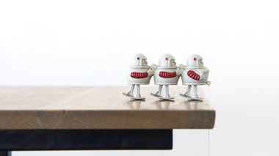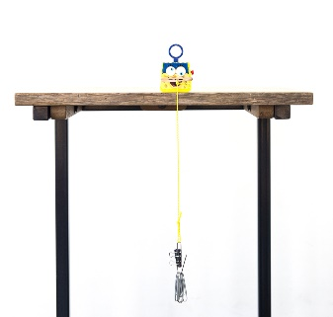
Store bought walker Do-It-Yourself walker

To Do and Notice
- When using a commercial walker toy (the horse, little green men), hang the mass over the side of a table or desk and let the toy walk toward the edge.

- When using a Do-It-Yourself walker, tie a string around the object, for example, a small toy. Attach sufficient mass (paper clips and/or binder clips, or anything that works) to the string so that when the object is about a foot from the edge of the table, with the mass hanging over the edge, a slight push on the object will start it sliding toward the edge. This is done by trial and error.

What’s Going On
Why does the toy walk? For the toy to move, you must apply a force that is at least as great as the frictional force trying to stop it. The weight of the mass pulls along the string and provides the force that results in the toy's motion. The string pulls diagonally, though, and only the horizontal component of the force makes the toy move forward.
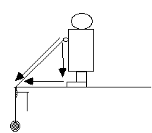
As the toy gets closer to the edge, the angle of the pull changes. The component of force pulling forward gets relatively shorter, and the component pulling down gets relatively longer. At the edge of the table, there is no component of force pulling the toy forward, so it stops!

