Some Fun Fly Stick Experiments
- Bend a thin stream of water.
Important: Place a plastic bag over the end of the Fly Stick to keep it dry.

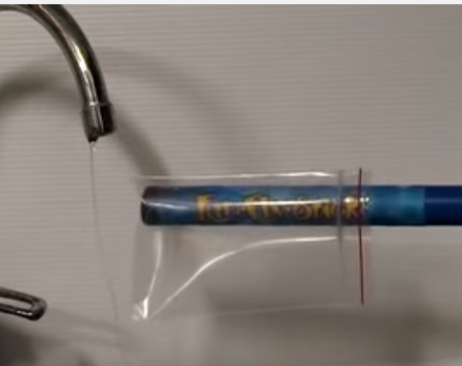

- Move an empty soft drink can.
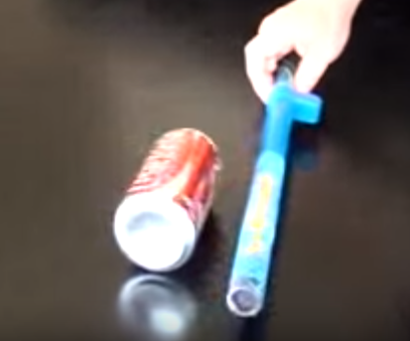

- Launch “flying saucers”
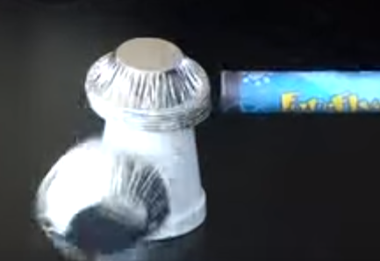

- Make a “drummer” with aluminum ball on string
