Science is Fun with Talkie-Tapes
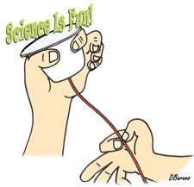

TO DO AND NOTICE
- Attach the pointed end of the red plastic strip to a plastic cup, file card, balloon, etc. with a piece of tape.
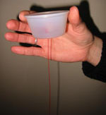

- Quickly slide your thumbnail down the grooved side of the strip and listen carefully. You should hear “science is fun!”
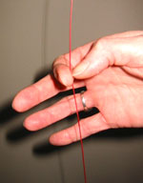

WHAT’S GOING ON?
The recorded information on a Talkie Tape is spread out along a 24-inch red plastic strip. On one side of the strip is a series of ridges and pits. These high and low points contain information about the frequency and loudness of the sound that was used to produce them. During “playback,” your thumbnail takes the place of the needle found on a conventional record player. The sound is amplified by forcing something with a larger surface area (a cup, file card, balloon, etc.) to vibrate. This vibrating surface in turn moves the air molecules that carry the sound to your ears.

