Pretty Cagey
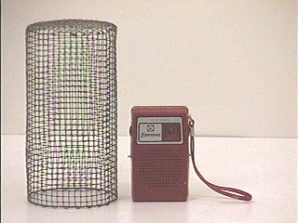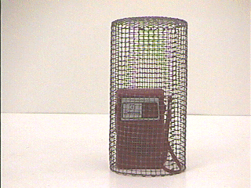

To Do and Notice:
1. Turn on the small battery-powered radio and tune it to an FM station.
2. Lower the radio into the wire cage. Can the sound still be heard when the radio is in the cage? Can you explain this effect?
What’s Going On?
The metal surrounding the radio in this demonstration is often referred to as a Faraday cage. A Faraday cage is an enclosure of metal or metallic meshwork. If a region in space is completely surrounded by a Faraday cage, electromagnetic waves are effectively screened from the enclosed region. Likewise, electromagnetic effects produced inside the cage cannot permeate the enclosure. Named for physicist Michael Faraday, who built the first one in 1836, Faraday cages may be found in a variety of settings.
A common example of a Faraday Cage is a metal automobile body. Contrary to a common belief, you are safe in a car during an electrical storm not because of the rubber tires but because of the shielding effect of the metal that surrounds you. Bridges supported by metal girders may interfere with cell phone and car radio reception for the same reason.

