The Ping Pong Ball Color Mixer

Inspired by a TPT article by Gorazd Paninsic¹, the tri-color, ping-pong ball color mixer is an inexpensive, readily assembled device for demonstrating additive color mixing. The tri-color mixer consists of a single, flashing, LED encased in a white ping-pong ball. The tri-color LED has a built-in chip that sequentially flashes each primary color quickly for about 5 seconds, and then slowly fades the colors in and out over the next 30 seconds. The complementary colors (cyan, magenta, and yellow) and white are created by the mixing of the three primary colors. Three “AA” cells in a battery holder serve as both power source and base for the apparatus (Fig. 1).

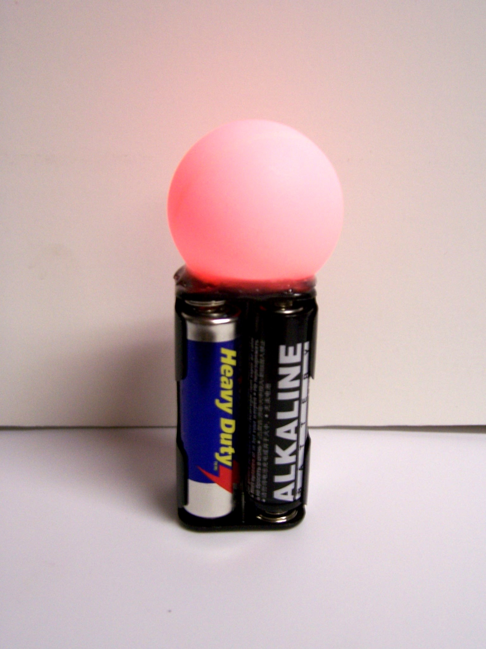
Fig. 1. The tri-color, ping-pong ball color mixer

The ingenious Planinsic color mixer employs three discrete LEDs (red, blue and green) to illuminate the inner surface of a ping-pong ball. Connected to potentiometers, each LED can be precisely controlled. Thus, a wide range of colors may be produced. The insertion of wire baffles in tiny slits in the ping-pong ball permits the production of colored shadows. While the color mixer described in this note lacks these features, it does allow the hands-on study of color mixing without the need for slide projectors or colored spotlights.

Key to the operation of both mixers is the use of a ping-pong ball as a screen. In the case of the tri-color mixer, the LED’s lens projects colored circles of light on the top of the ping-pong ball. When these colored circles overlap, one is reminded of the familiar color mixing diagrams found in most physics texts. Because the interior surface of the ping-pong ball scatters light with equal intensity in all directions, the additive combination of the projected colors is seen at all viewing angles. (Fig. 2).

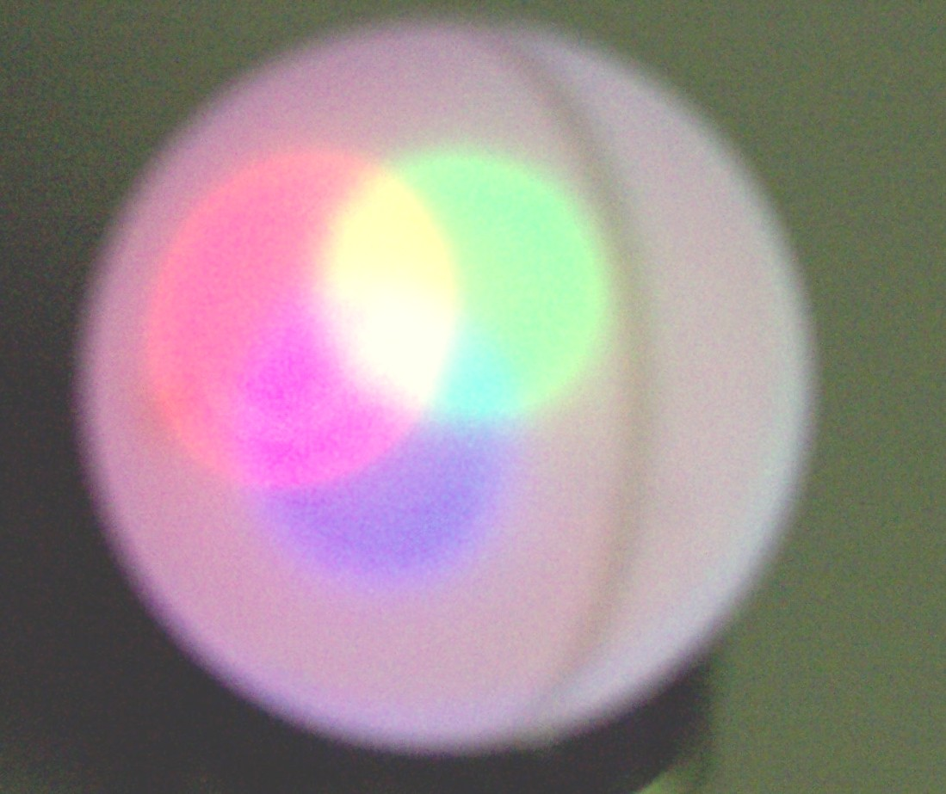

Fig. 2. The ping-pong ball displays the additive combination of the primary colors as well as the primary colors themselves. Here red, blue and green combine to produce white.

Detailed instructions for building the tri-color LED color are given below.
References
1. Gorazd Planinsic, “Color mixer for every student,” Phys. Teach, 42, 138-142 (March 2004).

Resources: The components in the tri-color color mixer include a white ping-pong ball, a four “AA” cell battery holder, three “AA” cells, and a flashing, red, green and blue LED. The flashing, red, green and blue LED (Catalog number LED-95) and holder for four “AA” cells (Catalog number BH-342) may be obtained from All Electronics Corporation (http://www.allelectronics.com/index.html). The cost of the LED and the battery holder are $2.50 and $0.80, respectively.

Ping Pong Ball Color Mixer Construction Details

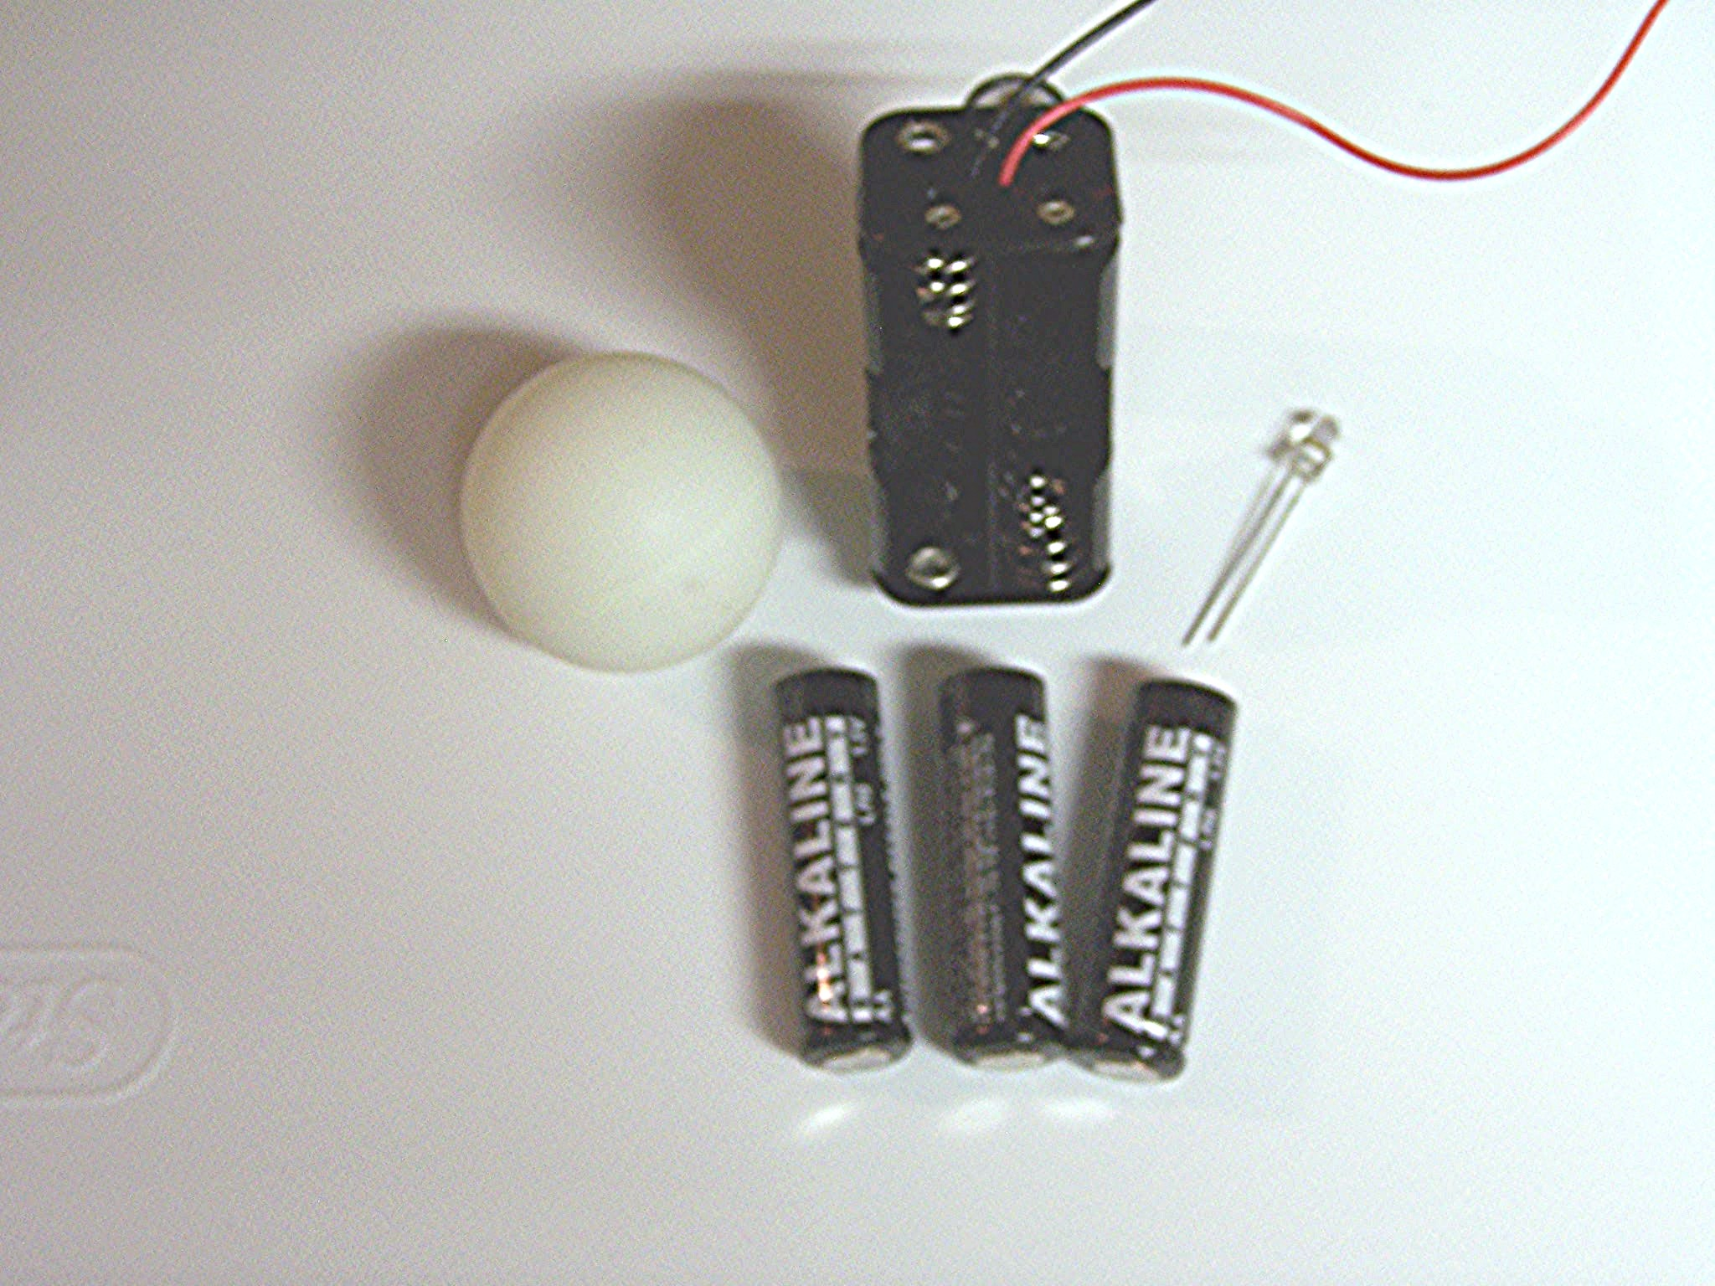
Fig. 1.

1. Cut off the black lead as close to the holder’s surface as possible. Run the red lead through the hole shown on the right in Figure 2. (Note: Since the LED operates on 3.5 v, a jumper wire is used in lieu of the fourth battery.) The polarity of both the red lead and the hole is positive. Examine the LED. Note that one lead is slightly longer than the other. The longer lead is the positive side of the LED. Pass the positive LED lead through the hole on the right side of the battery holder and the other LED lead, the negative lead, through the hole on the left hand side of the battery holder. The negative LED lead should pass through one of the top coils of the spring terminal as shown in Figure 2. Bend the ends of both leads up and around the top of the battery holder (see arrows in Fig. 2).

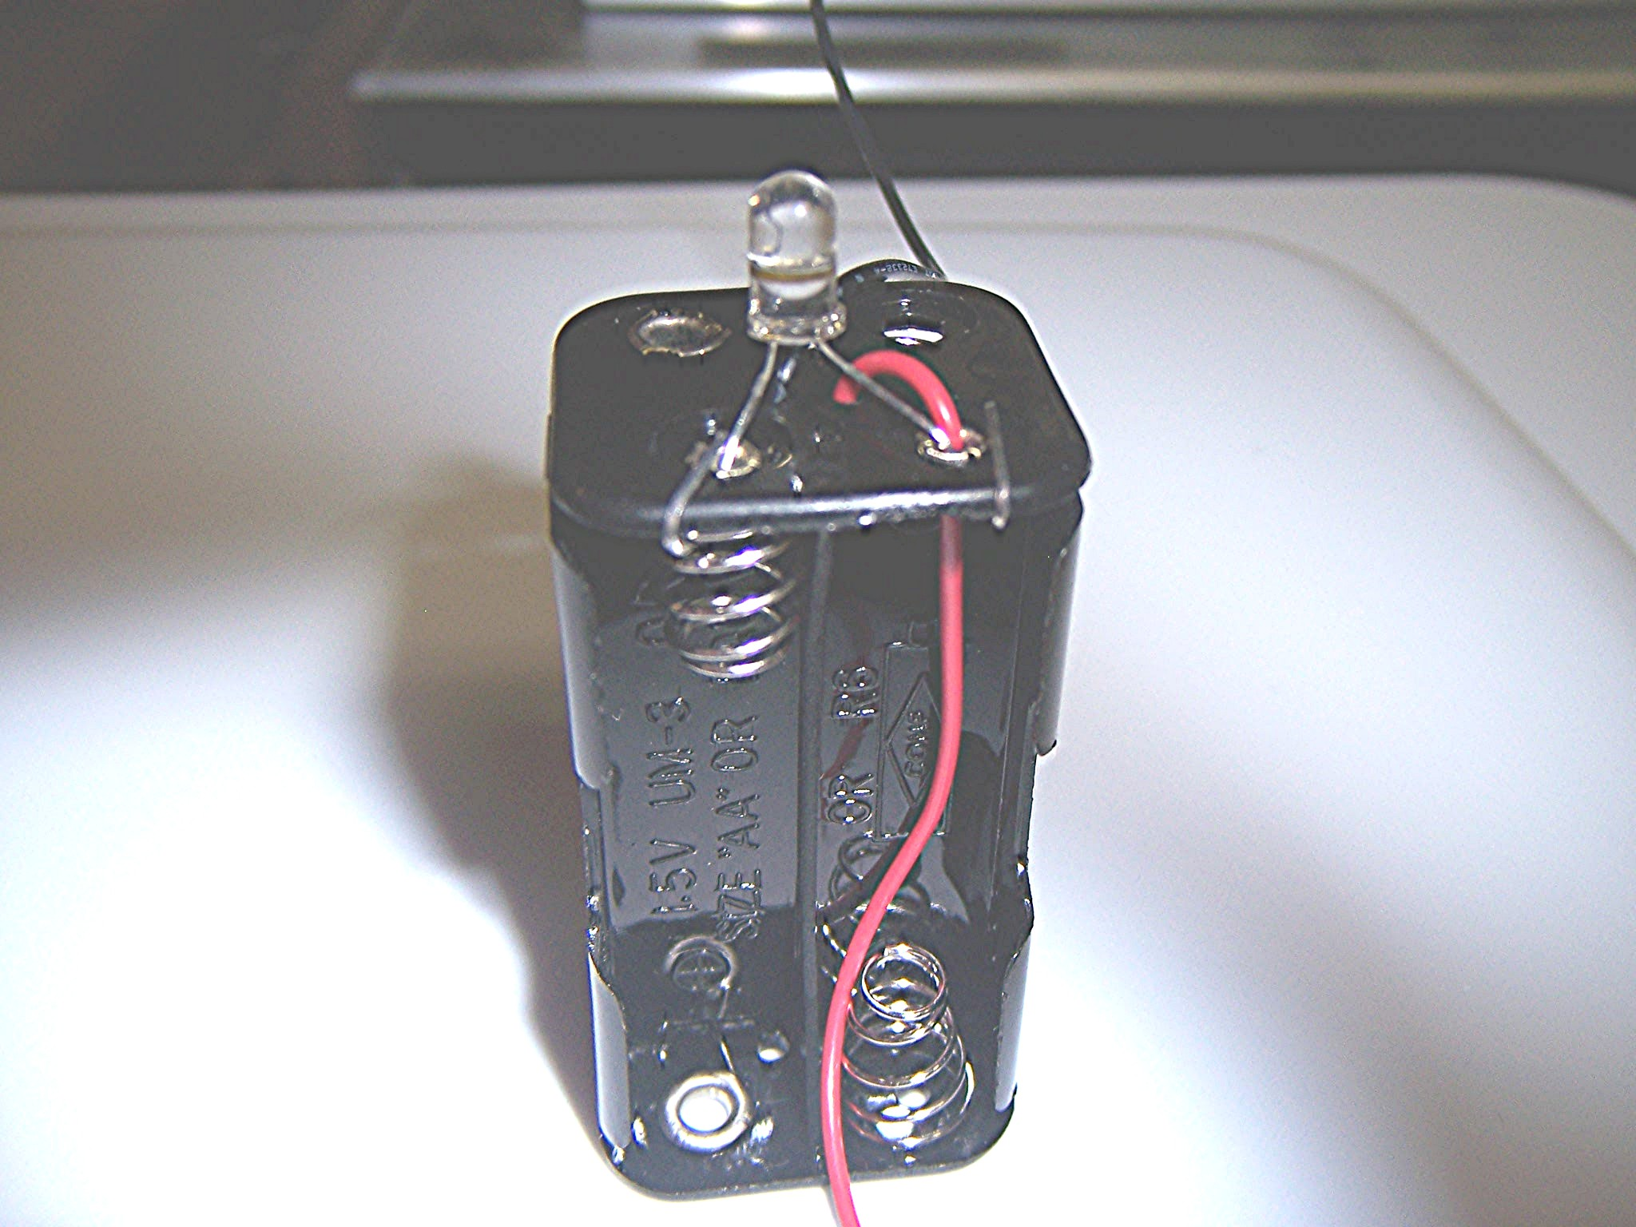

Fig. 2.

2. Reduce the length of the red lead so that it reaches the spring terminal at the bottom of the battery holder. Be careful not to cut the lead too short. Solder the red lead to the spring terminal and the two LED leads to the two terminals on the top of the battery
holder. The yellow arrows in Figure 3 indicate where soldering is required.

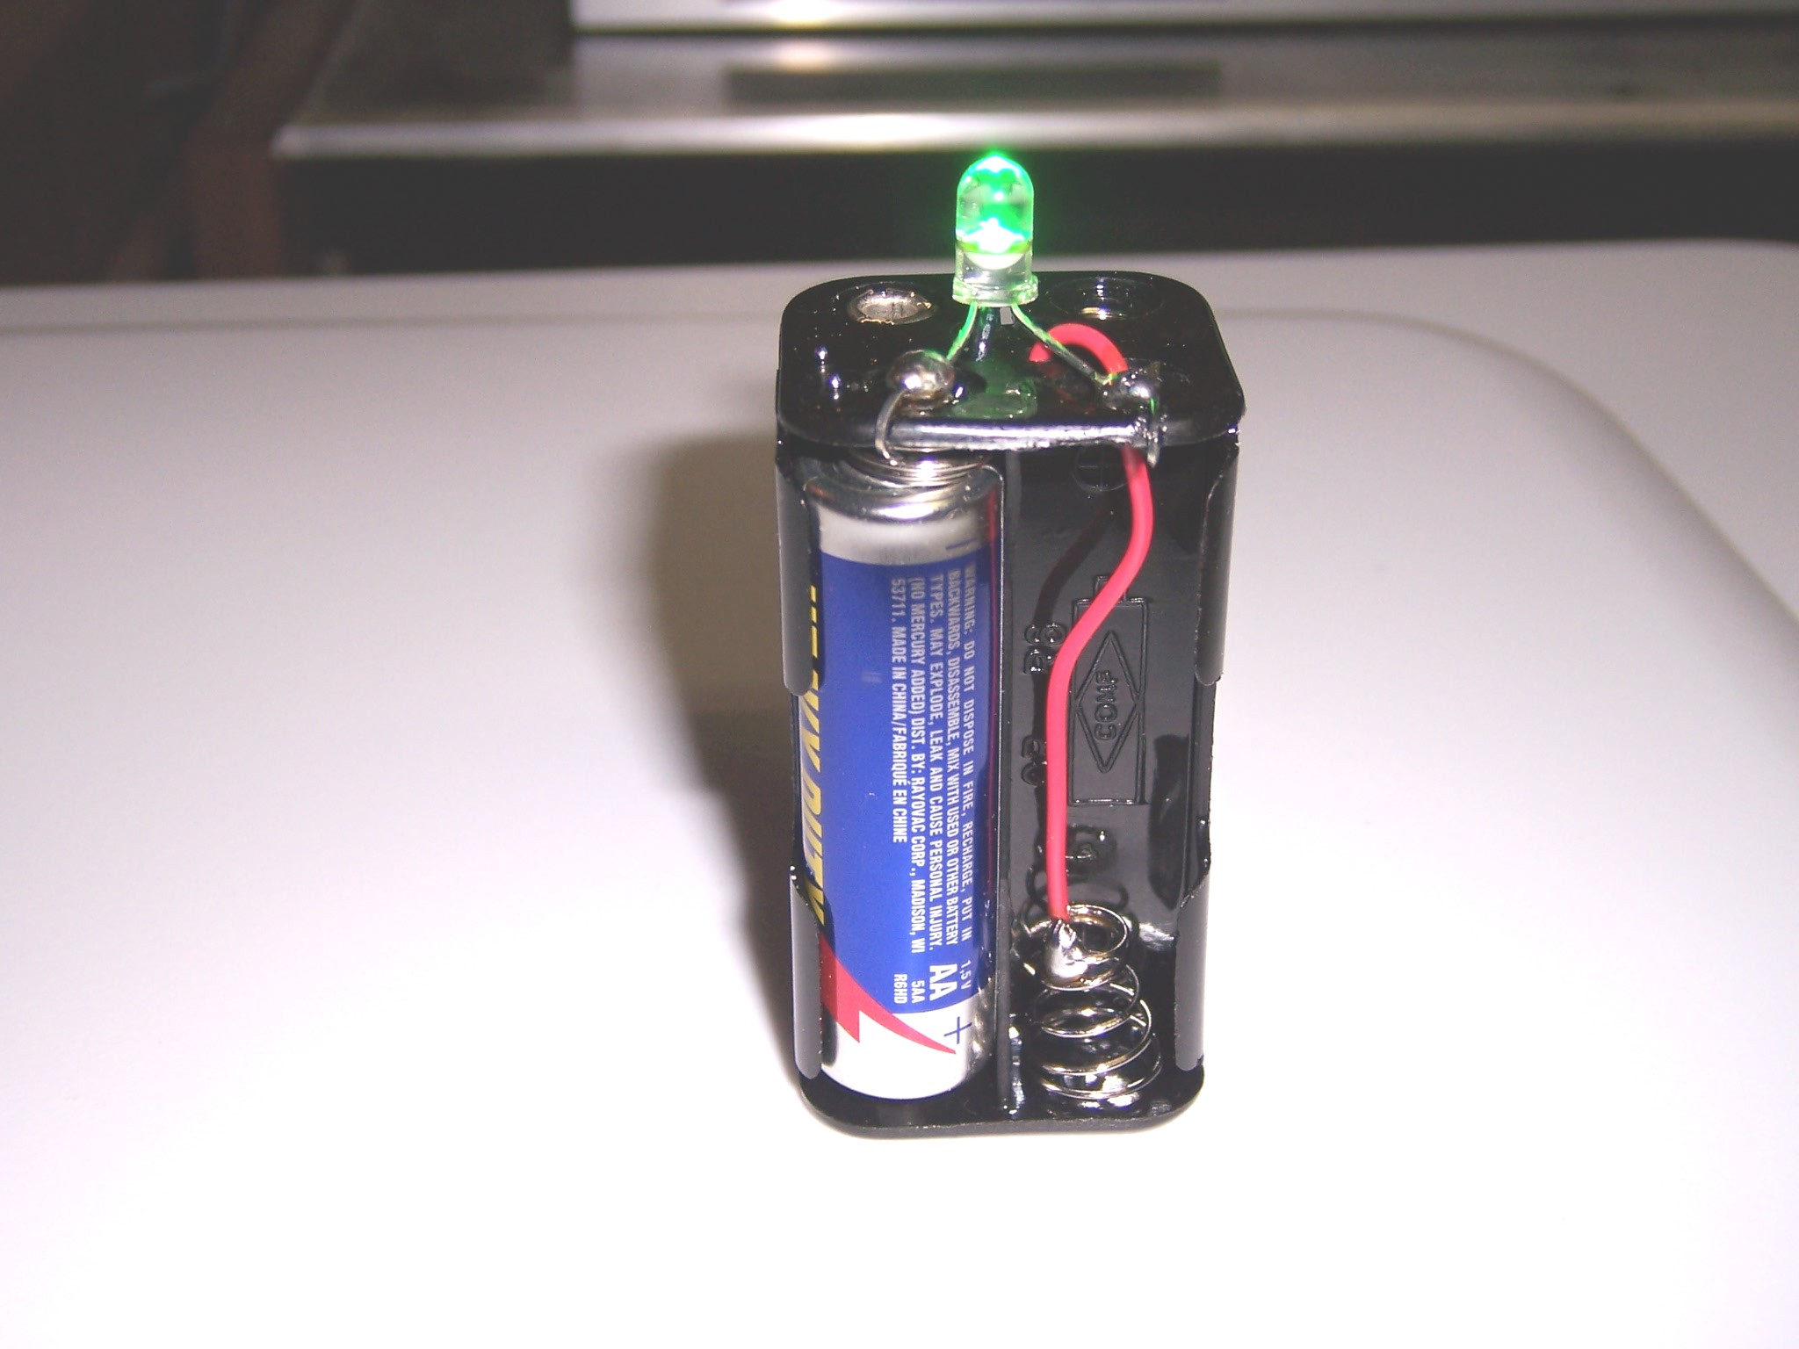
Fig. 3.

3. Make a hole in the bottom of the ping pong ball by using the hot tip of a soldering iron. For cosmetic reasons, the hole should probably be made in the ball’s printed area. The hole should be large enough to accept the LED.

4. Slide the LED into the hole in the ping-pong ball. To secure ping-pong ball to battery holder, deposit a generous bead of hot glue in the space between the bottom of the ping-pong ball and the top of the battery holder.

5. Insert three “AA” batteries to activate color mixer.

