Music Box Marvel
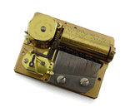
1. After gently winding the music box, listen to the sound
it produces. Is the sound very loud?

2. Now bring the music box in contact with a Styrofoam
or paper cup, tabletop, window, or other surface. Is
the sound louder when the music box is in contact
with a solid object? Why do you suppose this is so?

3. Which of the objects makes the sound the loudest?
Which objects tend to be the least effective
amplifiers?

