Making Waves

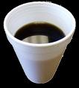

Fill a Styrofoam cup to the top with water. Drag the base of the cup along a smooth surface such as a Formica, slate, or polished wood tabletop. You will find that, by adjusting your pressure on the cup, you will be able to cause it to vibrate. The vibrating cup will produce a sound and set the surface of the water into vibration.

Carefully examine the surface of the water while it is vibrating. Describe what you see. What do you suppose produces the intricate pattern seen on the surface of the water?

