Look Ma, No Hands!
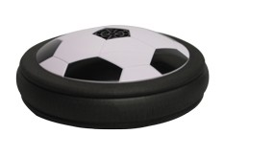
Part A. With Disk turned off.
- Place the disk on the table. Now give the disk a push. Describe the motion of the disk while you are pushing on it.
- Stop pushing the disk. Describe the motion of the disk after you remove your hand. What forces act on the disk after you remove your hand? How do you know?

Part B. With Disk turned on.
1.Place the disk on the table. Now give the disk a push. Describe
the motion of the disk while you are pushing on it.
2. Stop pushing the disk. Describe the motion of the
disk now. What forces act on the disk after you remove your
hand?

Conclusion
Is a force, such as applied by your hand, always needed to keep an object moving? Why or why not?

