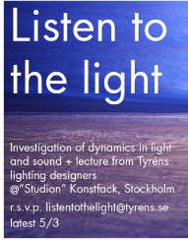

1. Connect the solar cell to the amplifier/speaker as shown in photo.

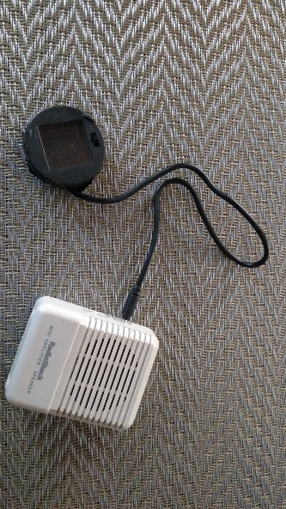

1. Describe what you hear after turning on the amplifier/speaker. What do you think is causing this sound?
2. Pass the beam from a flashlight back and forth across the solar cell. Describe what you hear. What is going on here?
3. Now “listen” to the light produced by the various light sources at this station. Describe the sounds produced by each source. Why do you think the light sources produce these sounds?
4. Direct a television remote at the solar cell. What does this tell you about a solar cell’s ability to see “invisible,” that is, infrared light?
5. Examine the sounds produced by other light sources. For example, a computer monitor, cell phone or tablet screen, or the digital readout on a kitchen appliance.