Observing Energy Transformations Using Genecon Generators
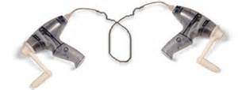

1. Clip the two leads of a Genecon generator to the leads of a small light bulb. What happens when you turn the generator’s handle? Describe the energy transformations that are occurring as you light the bulb.

Adjust the rate at which you turn the handle. What happens to the brightness of the bulb as the handle is turned faster?

2. Clip the leads of your generator to the capacitor’s leads. The capacitor may be a black square object with two wires sticking out of it or a round device that looks like this:
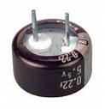
Now turn the handle of the generator for approximately one minute and then let go of the handle. What happens? In terms of energy transformations, what is happening?

3. Connect the leads of the generator to the two pins on the resistor/ thermometer device. The resistor/thermometer device looks like one the objects shown in the figure below.

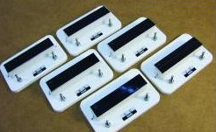

Turn the handle of the generator for several minutes while keeping your eye on the liquid crystal thermometer located on the top of the device. Describe what you observe. What energy transformations are taking place?

4. Connect the two Genecon’s clips together (see image at top of page). Now turn the handle of one Genecon and observe the handle of the other Genecon. Describe the function of each Genecon. Can the roles of the two Genecons be reversed?

