Egg in a Beaker
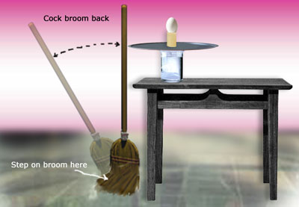
1. Fill a medium sized beaker or a wide-mouth glass 1/2 full with water.

2. Place the beaker, a pizza pan, a cardboard cylinder
fashioned from a file card, and a hard-boiled egg near the
edge of a table as is shown in the figure. The egg and
cylinder must be directly over the beaker. Also, the pizza pan
must extend beyond the edge of the table.

3. Place the broom handle next to the edge of the pizza
pan. With your foot on the bristles of the broom, “cock” the
broom by pulling the handle away from the pan. This will put
the handle under tension.

4. Release the handle. With luck, the egg should drop into the beaker.

5. Why did the egg fall straight down and not move with the
cardboard cylinder and pizza pan?

6. Do you think the mass of the object placed on the cylinder
matters? You may wish to check your answer by replacing the
egg with a ping pong ball.

