Edison Record Player
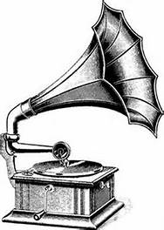

- Turn on the record player turntable.

- Gently lower the needle that’s located at the end of the Styrofoam block, or cardboard cone, into the record’s groove.

- Adjust the pressure of the needle in the groove by gently lifting the Styrofoam block, or cardboard cone.

- Enjoy the music!

