Connecting with the Energy Ball Or…. Energy Stick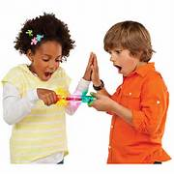
1. Place your fingers on both of the metallic contacts on an Energy Ball or Energy
Stick. Notice that the ball/stick flashes and produces a tone. This indicates that a
current is flowing through your fingers and a portion of your body.

2. Form a series circuit with two or more students as shown in the figure
below. See what happens when two people break the circuit.
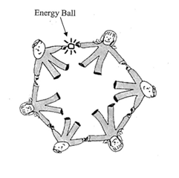

3. It’s fun to see if there is a limit to the number of people you can
include in your circuit. Try it!

4. To demonstrate a parallel circuit with the Energy Ball, get in a
formation that looks like a ladder with two lines of students
holding hands connected by students between the lines. What happens
as pathways, that is, students connecting the lines, are removed one by
one?
