Colored Shadows
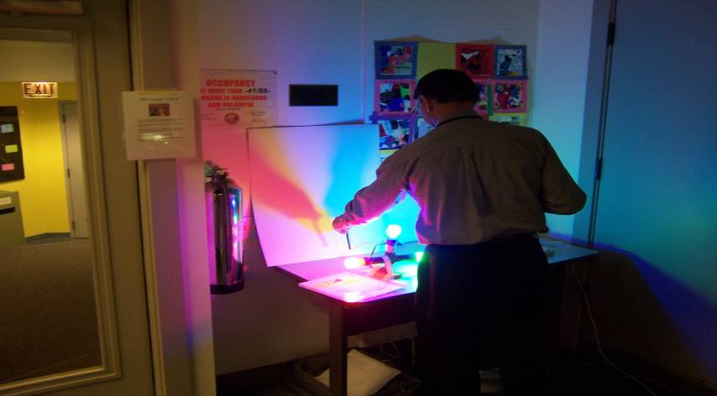

1. Look at the screen. You will see that the red, green, and blue lights make the screen look white.

2. Place an object, like your hand or a pencil, between the light bulbs and the screen. What do you see?

3. Move the object back and forth until you make six colors on the screen. What do you think makes all these colors?

4. Notice that when…

- the green light is blocked, the red and blue lights combine to form magenta.
- the red light is blocked, the blue and green lights combine to form cyan (blue-green).
- the blue light is blocked, the red and green lights combine to form yellow.
- both red and green light is blocked, blue light will be seen.
- both red and blue is blocked, green light will be seen.
- both green and blue is blocked, red light will be seen.
- all three colored beams are blocked, the screen will appear black.

