Can a Motor also be a Generator?

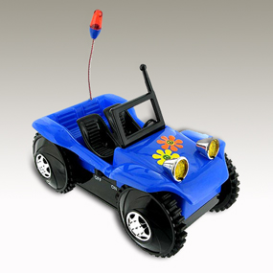
To Do and Notice
- Turn the toy car on by using the switch on the side of the car. (The switch may be on the bottom of the car.)

2. Place the car on the table. Does the car move? Are the headlights on?

3. Now, remove the battery from the car.

4. Watch the headlights as you use your hand to push the car quickly across the
surface of the table. Do the lights go on? How can this happen without
batteries?

5. From what you have observed, do you think that the car’s motor can also
function as a generator?

