Black Hole

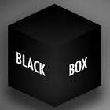

1. Look at the black hole at the center of the
black box.

2. What do you think is the color of the inside
the box?

3. Open the box to see if you are right.

4. After seeing the inside of the box, why do
you think the hole appears black when the
box is closed?

