An Awesome Sound Experiment!
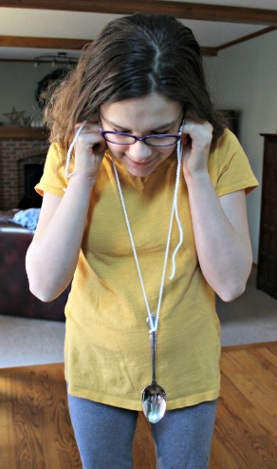
- Take the ends of the string and wrap them around the pointer finger of each hand.

- With the spoon hanging by the strings, have someone tap the spoon with a stick or ruler. Don’t hold the free ends of the string close to your ears. Describe what you hear.

- How does the sound reach your ears?

- Now, with your pointer fingers, place the free ends of the string on the little flaps of flesh that stick out over the opening of each ear (see photographs) Do not stick strings into your ears, but just outside.

- With the spoon hanging freely just below your waist, once again have someone gently hit the round part of the spoon with a stick or ruler. What do you hear now?

- How is the sound reaching your ears?

- How do you explain the difference in the two sounds?

