Anamorphic Art

The distorted picture below is an example of an art form known as anamorphosis. A small group of artists began working with anamorphic art during the Renaissance. Anamorphic drawings appear strange and almost unrecognizable to the unaided eye. However, when viewed in a reflecting cylinder, the distorted image regains its normal proportions. This technique is essentially the reverse of a fun-house mirror, which creates a distorted image of a normally proportioned person.

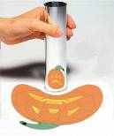
You can create your own anamorphic art by using a grid like the one shown below. An image drawn on the square grid is transferred, point by point, to the cylindrical grid. The distorted image is then transformed into a recognizable shape by viewing its reflection in the cylinder.

